Individual Logbook

Week 15
Dave Sushames
2026
Contents
Table 1
Discussion 1

Table
Category | Hours Completed
Team meetings
Client meetings
Advisor meetings | 1h 30m
Research
Development
Testing
Documentation | 6
Logbook preparation
Other
Total hours for this week
Running total of hours completed for Capstone | 348h 55m + X

Logbook content notes
Team meetings:
Client meetings:
Advisor meetings:
Tuesday 9-10:30: Bryce meeting
Research
See research log
Development
Documentation
Monday 8:30 – 12pm: Working on the Client closeout report, expanding on the summary, listing deliverables and their status, as well as key technologies.
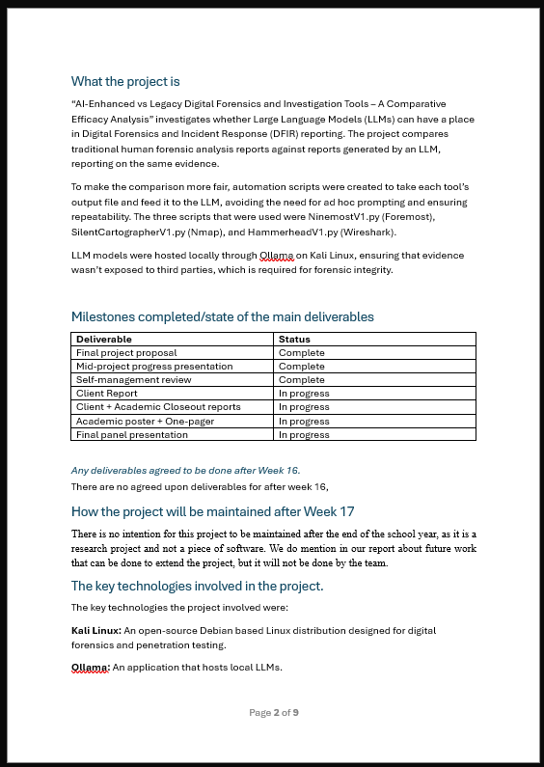
Monday 12:30-1pm: Reading through Sam’s Nmap_example report and putting it into the report comparison table. 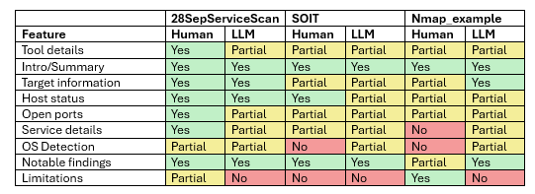
Monday 1pm-3pm: Academic closeout report, filling out the Testing and Suitability sections.